AVIDAnet Live - Firewall settings

The Televic AVIDAnet Live multimedia lab works as a server/client based network topology and to ensuring all the functions work correctly. The Televic AVIDAnet lab require any firewalls set at the PC level to either be disabled or have the following ports opened for communication between Teacher PC and Student PC.

Description | Port | IP Address
Client – TCC connection  (for login and commands) | 17777
AVService – TCC connection  ( for commands handled before student logs in e.g. block USB) | 17778
AIR client – TCC connection  (voting activity) | 17779
Sonus – TCC connection  (reserved but not in use yet) | 17780
Mobile remote connection  (remote control of the TCC from tablet) | 17781
Web socket server  (remote control of the TCC from tablet – student screen transfer) | 17782
HTTP server  (web socket alternative for remote control of the TCC from tablet – student screen transfer)  (transfer of ZIP Edumatic content package to ACC) | 17783
Edumatic service host  (reserved for integration with Edumatic – not in use yet) | 17784
Client monitoring  (screen monitoring by TCC) | 8079
Client monitoring (Virtualized) | 8079 and below
Client / Sonus connection | 8179
Client / Sonus connection (virtualized) | 8179 and below
FTP  (command channel) | 21
FTP passive mode  (data transfer) | 35000-35999
Chat Service | 4321
Screen transmission | 16777-65535 UDP | 224.3.2.x (x = roomID)
Broadcast TCC IP address/port | 18777 UDP | 239.192.2.0
Audio Transmission | 16777-65535 UDP | 239.192.1. x (x = roomID)
Video Transmission | 16777-65535 UDP | 239.192.2. x (x = roomID)
License server | 1234
 | 10080

Exceptions

To add the applications to the exceptions list in the local windows firewall, follow the simple steps below:

Step One

Open the control panel and select the Security Centre icon

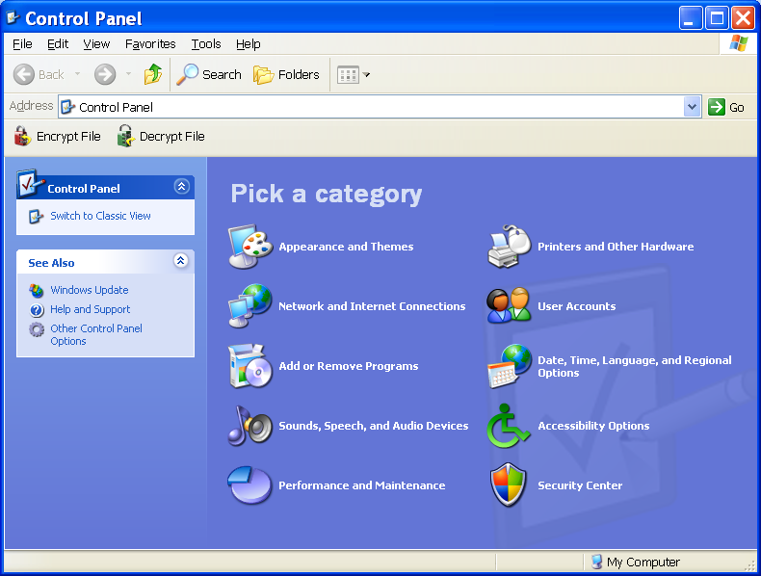

If in classic view then select the windows firewall option
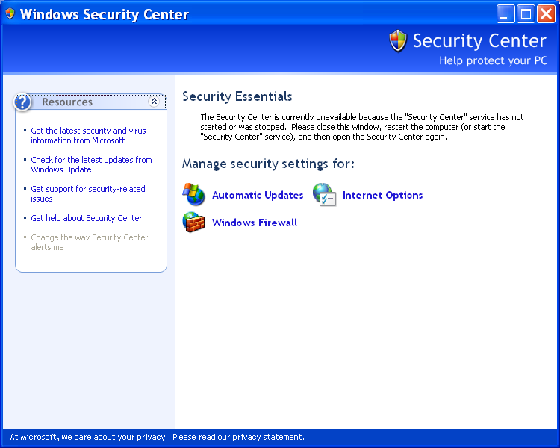

Step Two

In the windows firewall window select the Exceptions tab at the top

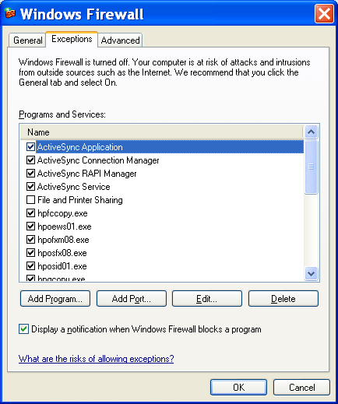

Step Three

Click the Add Programs button

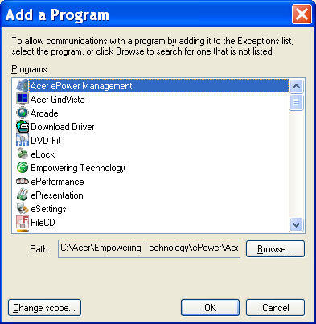

Step Four

Click the browse button

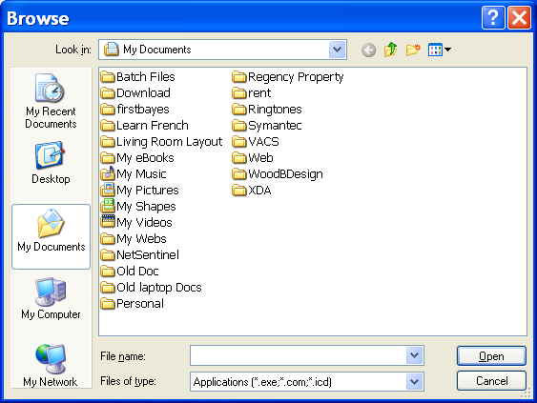

Step Five

Locate the Avidanetboot.exe application and add it to the exceptions list

Avidanetboot.exe is located in the following dir:
C:\program files\artec\client

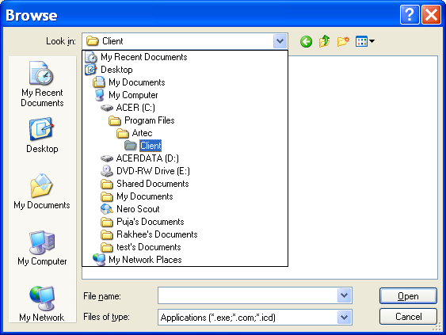

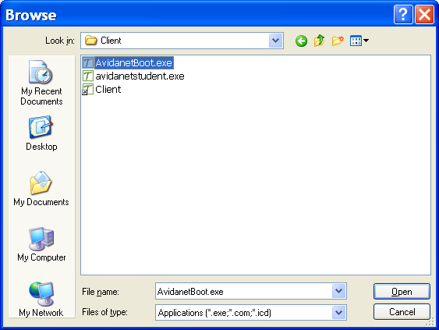

Step Six

Click the Open button and you will notice the application will now be in the exceptions list.

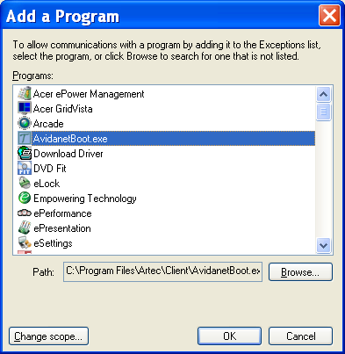

Step Seven

Add the following applications to the following PC types:

Student PC’s

- Avidanetboot.exe located in c:\program files\artec\client
- Avidanetstudent.exe located in c:\program files\artec\client

Teacher PC
- Teacher_gui.exe located in c:\program files\artec\TCC
- Avidanetboot.exe located in c:\program files\artec\client
- Avidanetstudent.exe located in c:\program files\artec\client

